JCSWCD Board Meeting: July 24, 2024
Ellen Hammond (Conservation Specialist)
Red = highlights to discuss
A. Drought Resiliency
- Group
  - Next Q meeting is August. Need to send out a Doodle.
  - Slow progress
    - Mapping juniper projects
    - Working with NRCS and the Croplands Workgroup to figure out how to measure soil health in NUID
  - Trying to find funding for the 1-minute videos
- June 11 Soil Health Field Day: 40 participants. NRCS and I hope to provide trainings/something this winter.
- Working with Lars to shift some of my funding from ODA to NRCS
- Using soil/other sensors in Jefferson County as part of JeffCo broadband expansion: seeking pilot farmer!
B. SIA
- Continuing with WQ sampling and flow monitoring; start springs next year.
- Ryan collecting for me this summer
- SIA Restoration grant: Roberts vegetation and livestock mgmt.
  - Figuring out livestock water issue

C. Pesticides
1. PSP (most funding going to Ryan and me for outreach)
- 7 Pesticides of Concern (POC)
- Working on a general outreach flyer for PSP and POCs
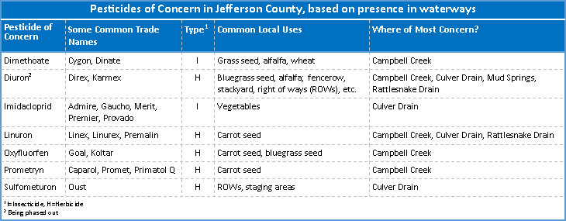
2. EPA Toxics – assist Ryan with
1. 3 peer-to-peer field days
2. printing weed booklets
3. tracking and reporting

D. Other
- OACD Working Lands Committee (soil health grant hub)
- Maintain website, Facebook page, and YouTube Channel
  - West Jefferson SWD?
- Getting blue truck maintenance up to date
- Assist Kate on request

